Dear Parents of 2021-22 Elkins HS Students:

I know this letter is a little long, but I sincerely hope that if you bear with me, you will find the information to be important and helpful.

My name is Bonnie Bonnette, and I am one of the two Academic Decathlon/Academic Octathlon sponsors for Elkins High School. The other coach is William Corrington. Elkins High School has had an Academic Decathlon team every year since the school opened in 1992. We are actively recruiting students for the team and the accompanying course, Multidisciplinary Studies.

Academic Decathlon is a program for 11th and 12th grade students, and its lower grades counterpart, Academic Octathlon is a program for 9th and 10th grade students. FBISD provides and supports a course that students can take in order to prepare for these competitions. The course is called Multidisciplinary Studies, and it can be taken all four years of high school if students are interested. 9th and 10th grade students receive the same GPA boost as a Pre-AP course, and 11th and 12th grade students receive the same GPA boost as an AP course. Taking the course usually has a positive impact on a student’s GPA and class rank.

In addition to being a benefit to the student’s GPA and ranking, it is also the MOST well-recognized and well-respected academic competition for applying to college. College admission officers are more familiar with Academic Decathlon than they are with any other academic competition that students can do, such as UIL Academics, Math and Science Competitions, and writing competitions. The reason is that it is a nation-wide program that encompasses all of the different academic disciplines.

Students who take Multidisciplinary Studies and prepare for either Decathlon or Octathlon gain valuable skills that are recognized and praised by college recruiters and admissions. They are stronger speakers, have interview skills that help them with those all-important college and job interviews, have knowledge in a wide range of subjects, and are flexible in their learning.

The program is also open to all students in high school regardless of their current GPA or academic level. A team consists of nine students, three who have a current GPA of 3.75 and above, three who have a GPA of 3.00 to 3.74, and three who have a GPA of 2.9 and below. The students in the class who do not make the team are still valued! We offer them the opportunity to study for UIL Academics and practice for the district competition and beyond. Although not nationally recognized, UIL is very important to all public schools in the state of Texas, and participation in UIL is another benefit to the transcripts for students applying to Texas colleges. UIL also has the added benefit of providing scholarships to many of the students who make the state competition.

I have included in this letter some specific information from the United States Academic Decathlon (USAD) organization. It comes directly from their website—www.usad.org. Please take a few minutes to look at the information I have provided. If your child is interested in joining, please have him or her contact the counseling office and let them know to change your child’s schedule to include Multidisciplinary Studies. It really will have a strong impact on his or her academic future.

**Contact Information for Elkins Counselors**

A-Ck     Ms. Kathleen Fey

[Kathleen.fey@fortbendisd.com](mailto:Kathleen.fey@fortbendisd.com)

CL-G      Mrs. Richerica Wolf

[Richerica.wolf@fortbendisd.com](mailto:Richerica.wolf@fortbendisd.com)

H-K       Mrs. Jourdan Wortham

[Jourdan.wortham@fortbendisd.com](mailto:Jourdan.wortham@fortbendisd.com)

L-O       Mr. Brian Williams

[Brian.willliams@fortbendisd.com](mailto:Brian.willliams@fortbendisd.com)

P-Sm     Mrs. Braiyon Sands

[Braiyon.sands@fortbendisd.com](mailto:Braiyon.sands@fortbendisd.com)

Sn – Z    Ms. Dina Powis

[Dina.powis@fortbendisd.com](mailto:Dina.powis@fortbendisd.com)

Please feel free to contact me if you need any additional information. My phone number is 281-634-9295, and my email address is bonnie.bonnette@fortbendisd.com.

Sincerely,

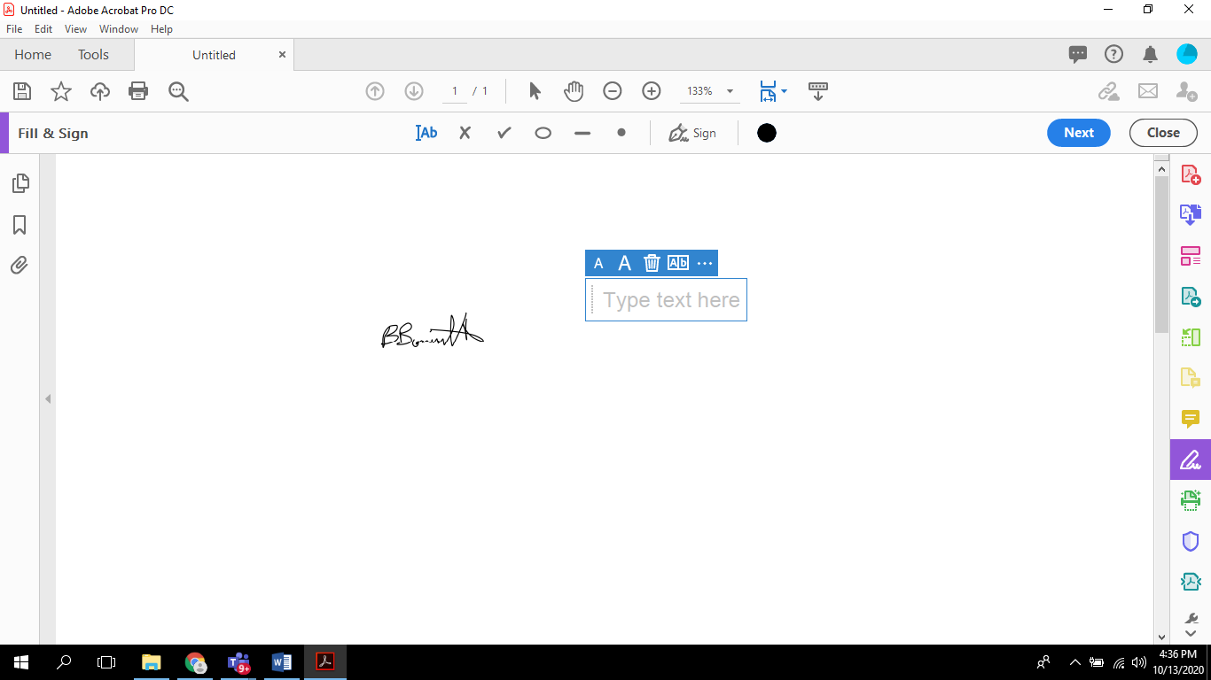

Bonnie Bonnette

**Welcome Letter**

There are lots of wonderful academic competitions out there.  You can go prove you’re the best writer, or the best physicist, or the best speller.

**Academic Decathlon isn’t about any of that, though.** It’s not about demonstrating how good a student you already are. It’s about daring to push your limits, to master college-level material and to practice skills, like public speaking, that might be wholly new to you. It’s about the people you’ll meet along the way—the coaches who will mentor you, the competitors who will challenge you, and the teammates who will become your lifelong friends.

My daughter competed in Academic Decathlonat three different schools in two states. At one school, she started the team herself, recruiting a teacher and her friends to give the program a try. At another, she joined a team with a long tradition. Both times, I watched her and her teammates share an incredible experience, navigating the challenges of teamwork, leadership, and time management. No other activity, she later said, better prepared her for university.

As Decathletes, you’ll learn an exciting new theme each year, themes like Russia, World War I, and New Alternatives in Energy: Ingenuity and Innovation. You’ll explore seven subjects connected to that theme, from art and science to math and economics. You’ll learn to move an audience not just with facts and rhetoric, but with confidence. And you’ll never do any of this alone. You’ll be working with a team—a team composed of students with a wide range of grades but a single shared goal.

You should join the Academic Decathlonnot because that goal will be easy to achieve, but because it will be hard. You and your teammates may study more than you ever have before, not knowing whether you will take home ten medals each—or none at all. The philosopher Mortimer Adler once wrote, “It is only by struggling with difficult books, books over one's head, that anyone learns to read.” I invite you to become part of a program that you may think is over your head, until you realize you can reach higher as a team. I invite you to struggle. And I invite you to learn—not just to read, but to understand; not just to win, but to lead.

Dr. Les Martisko  
Administrator

United States Academic Decathlon

**What Will I Learn?**

You’ll always learn something different. Each year, the Academic Decathlon® selects a new theme for teams all over the country to explore. The theme shapes an entire course of studies—and brings it all together. The more years you participate in Academic Decathlon, the more themes you’ll master. And, since our curriculum team develops these themes with special attention to [**national content standards**](https://usad.org/USAD/media/THE-ACADEMIC-DECATHLON%c2%ae-CURRICULUM-AND-NATIONAL-CURRICULUM-AND-CONTENT-STANDARDS/2020-21-USAD-and-Content-Standards_1.pdf), you’ll find you’re becoming not just a more knowledgeable Academic Decathlete, but a stronger all-around student.

**United States Academic Decathlon**®**Curricular Topics for 2021–2022!**  
   
The U.S. Academic Decathlon® is excited to announce that the overall curricular theme for 2021–2022 will be**Water: A Most Essential Resource**. Following is some general information on the topics in each of the subject areas. In addition to the events below, students also compete in **SPEECH**, **INTERVIEW**, and **ESSAY**.

* **SCIENCE**: The science topic will be an introduction to marine biology.
* **LITERATURE**: The literature curriculum will include critical reading, one long work of literature, and selected shorter works. The long work of literature will be *The Sea-Wolf*by Jack London.
* **ART**: The art curriculum will explore the impact of water on art, including subtopics such as ink wash painting, watercolor, water as a subject of art, and the use of water in architecture, sculpture, and environmental art.
* **MUSIC**: The music curriculum will explore the many ways water has influenced music, from musical instruments that rely on water to compositions inspired by water.
* **SOCIAL SCIENCE**: The social science topic will be the impact of water on human history.
* **ECONOMICS**: The economics curriculum will cover fundamental economic concepts, microeconomics, and macroeconomics and will include a thematic section on the economics of water.
* **MATHEMATICS**: The mathematics curriculum will cover permutations and combinations, algebra, and statistics.

The full subject area outlines will be posted on the U.S. Academic Decathlon website [**www.usad.org**](http://www.usad.org/) on May 1.

**Mission and Vision**

As a non-profit organization, we aim to inspire students of all achievement levels to work together to learn more than they ever thought possible.

Our **mission** is to promote learning and academic excellence among students of varying achievement levels by developing and providing multidisciplinary academic competitions using Academic Decathlon curricula.  
  
Our **vision**is to provide all students the opportunity to excel academically through team competition.  
  
Our **core values**include:

* The academic growth of students
* Challenging multidisciplinary learning
* Teamwork as a means to achieve self-knowledge and life skills
* Providing equal opportunities for students of different achievement levels
* The importance of inclusivity and diversity to learning and the human experience
* High standards of honesty and integrity
* Transparency in our relations and interactions with all of our stakeholders
* Excellence in our programs, services and activities
* Respect for diverse points of view.